**Sanika Kadam 2124UCSF1112**

**1.Introduction**

 Phone Call Program: Write a program to make phone calls. develop a contact app that allows users to select a contact and press a "Call" button to initiate a call to the selected number.

**2. Tools & Technologies Used**

* Android Studio
* Java/Kotlin (Java)
* Emulator or Physical Device

**3. Procedure & Steps**

**Step 1: Create a New Project**

* Open Android Studio and create a new project.
* Choose an Empty Activity template.
* Set the project name and package name.
* Select the programming language (Java).
* Screenshot
* 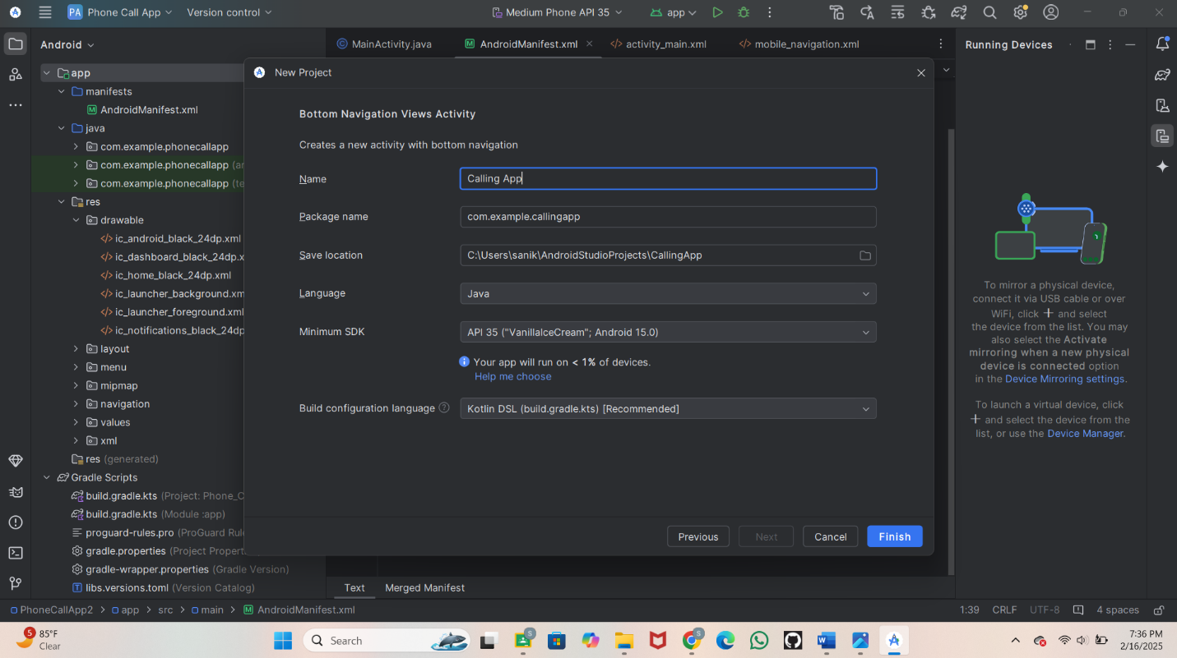

**Step 2: Designing the UI**

* Open activity_main.xml and design the layout using XML.
* Add UI components such as TextView, EditText, Button, etc
* Go on search bar and search edit then take phone option
* Then search fab take floatingActionButto and take phone image
* Edit the text Enter a phone no:

**Screenshot**

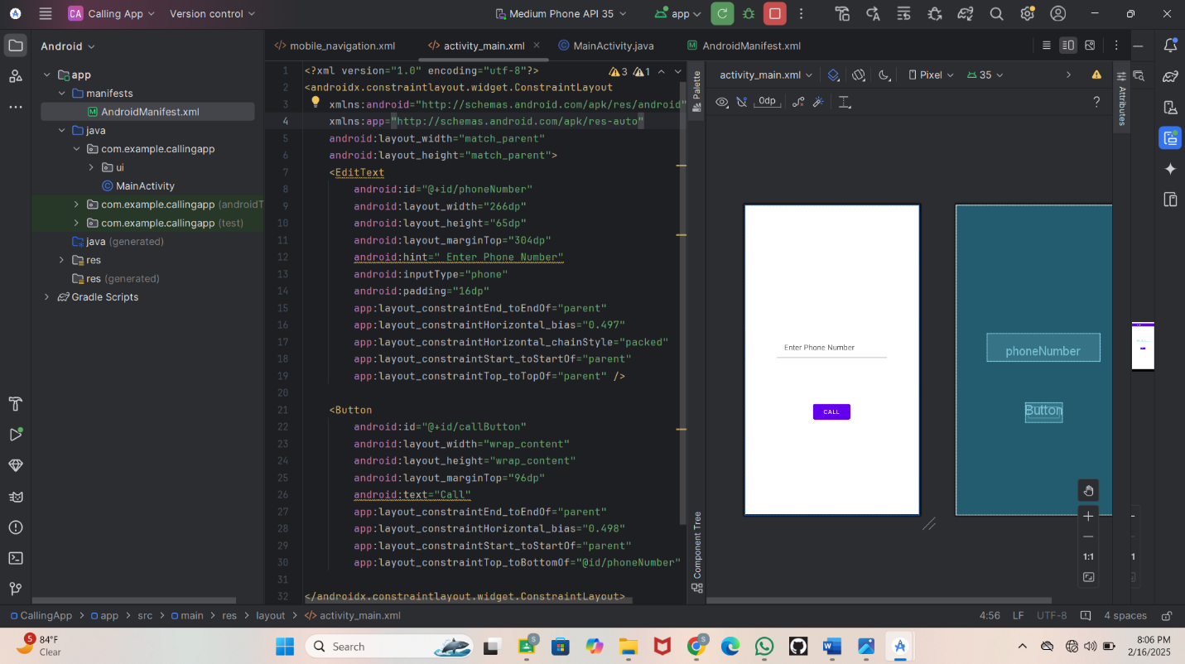

**Step 3:**

* Go on drawble take
* Then go on New Select Vector Assist
* Sreenshot

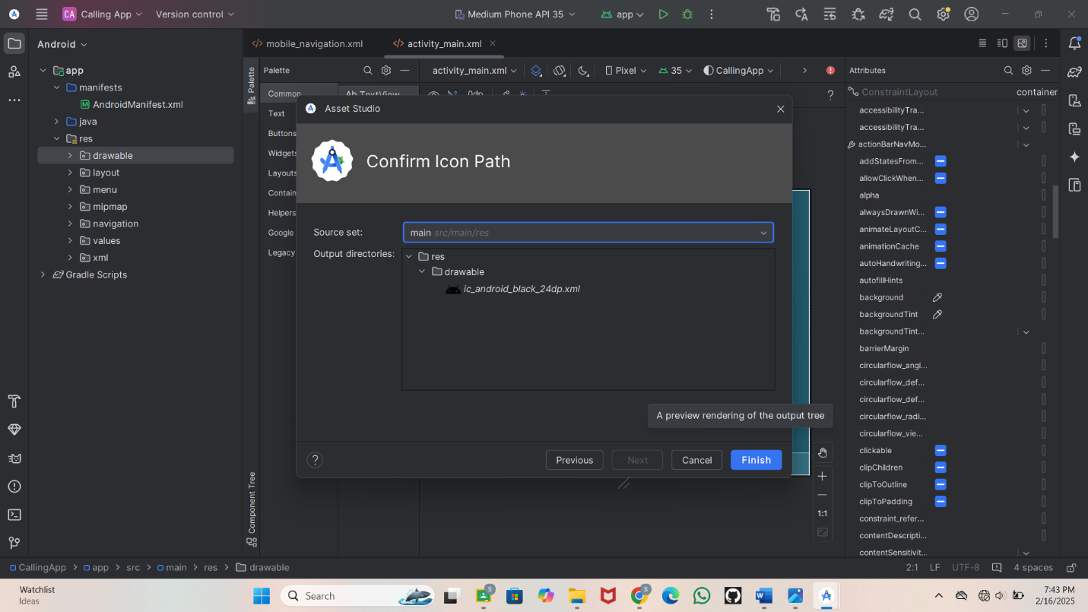

* **Step 4**
* Open Activity main xml .
* Edit the code
* Implement functionality such as button clicks, form validation, etc.
* Use necessary Android components like Intents, RecyclerView, Fragments, etc.
* Screenshot
* 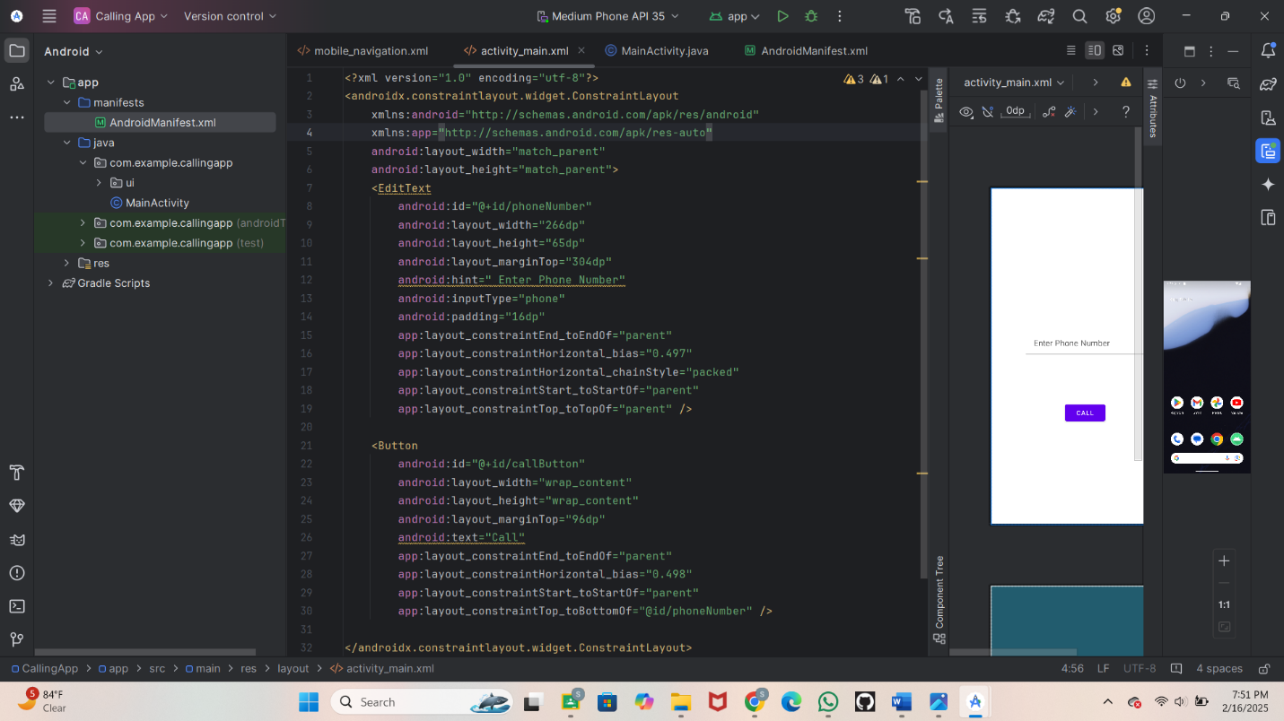

**Step 5**

* Take Android manifest.xml
* Edit the code
* Screenshot
* 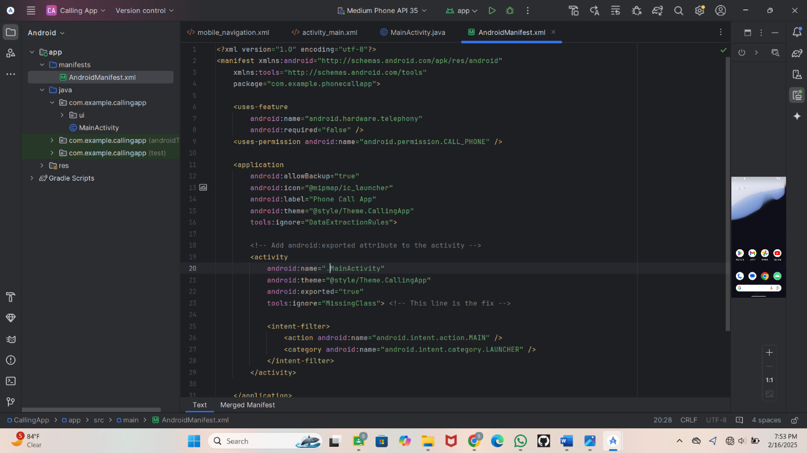

**Step 6**

* Go on java and take
* Main Activity.java
* Edit the code
* Screenshot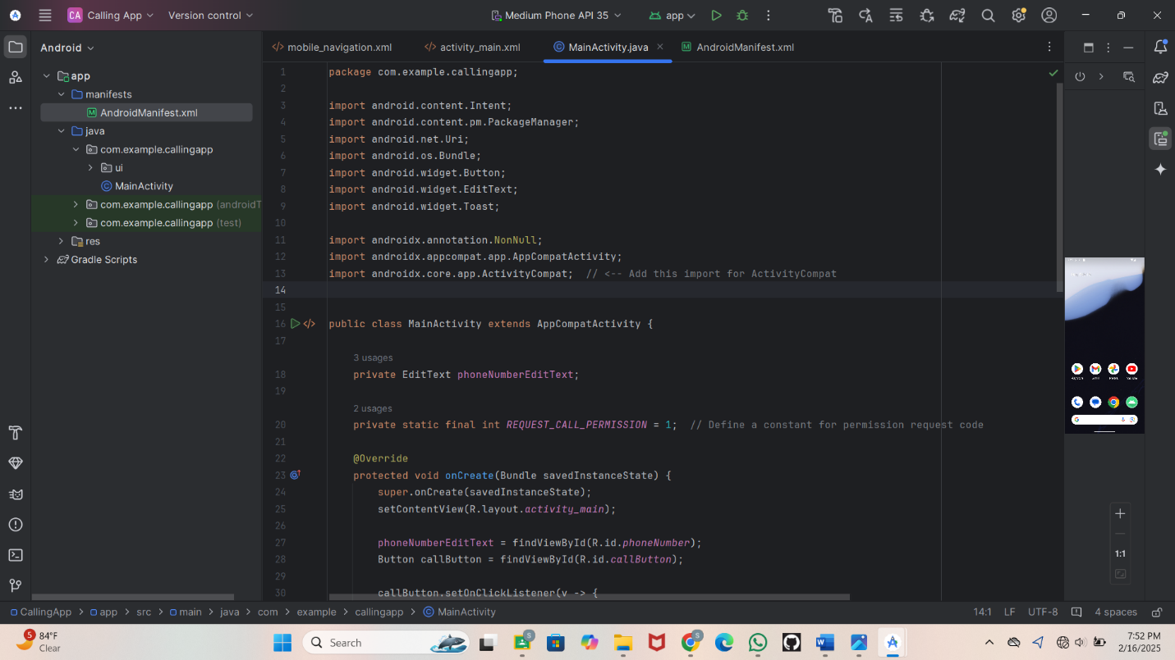

**Step 7**

* Running the Application on Emulator
* Click on the Run button in Android Studio.
* Select the emulator and launch the app**.**
* Screenshot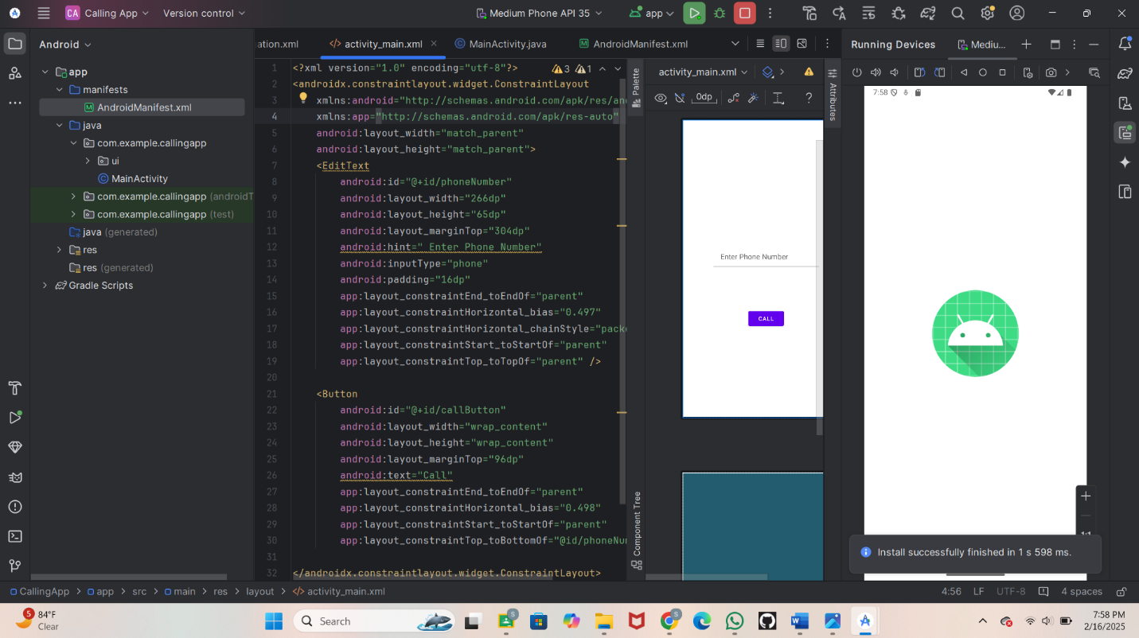
* **Step 8**
* After running the emulator
* 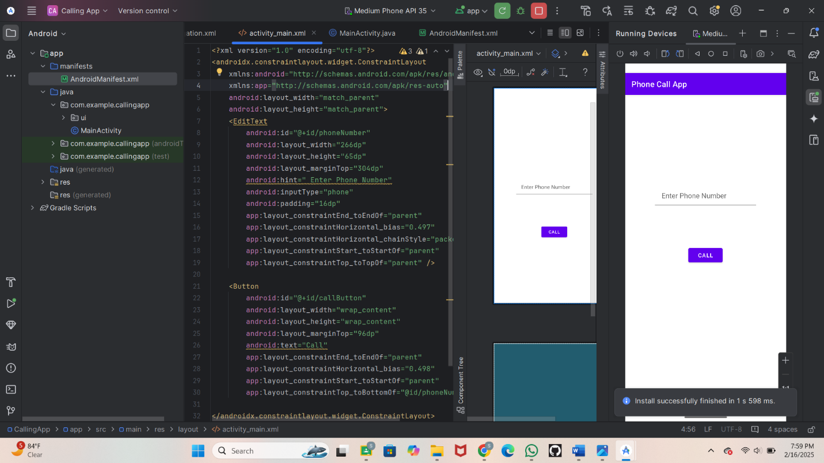

**Step 9:** Allow the permission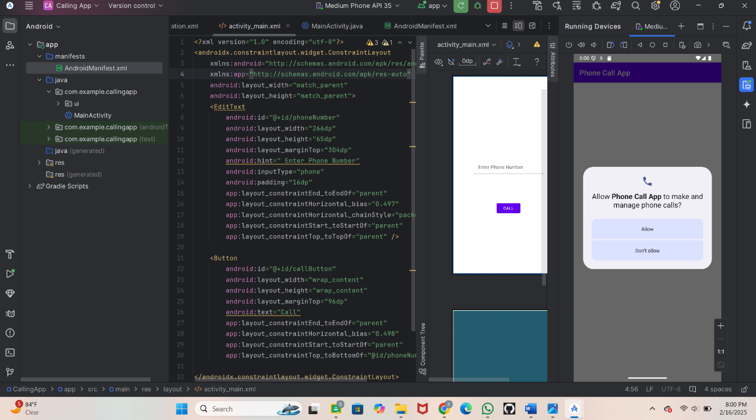

**Step 10**

* Enter the number
* Call the number
* Screenshot
* 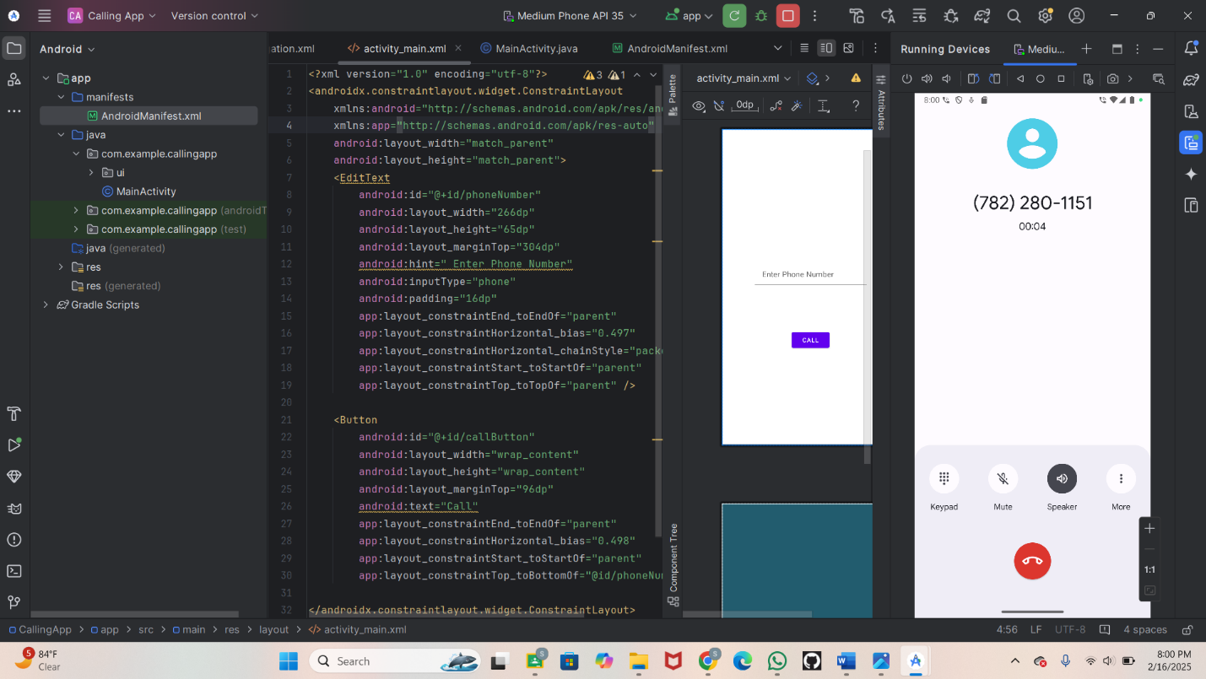
* **4. Conclusion**
* This app allows users to make phone calls easily with a simple interface.
* The phone calling app is a useful and essential tool for anyone looking to make calls on their mobile device.
* Easy to use